RETAIL SALES
ANALYTICS DASHBOARD
End-to-End Performance & Profitability Analytics — India Market
Project Report | Python • Streamlit • Plotly

Metric | Value | Metric | Value
Revenue | ₹22.90 Cr | Profit | ₹3.05 Cr
Orders | 2,192 | Customers | 497
Products | 63 | Categories | 4
Regions | 4 | Avg. Shipping | 3.7 days

Analysis period: January 2024 – October 2025
Prepared as a professional analytical report | September 2026

Contents
1. Executive Summary
2. Business Objective & Analytical Scope
3. Data & Methodology
4. Solution Architecture & Technology Stack
5. Dashboard Structure
6. KPI Summary
7. Detailed Analysis & Insights
8. Recommendations
9. Conclusion
Appendix A — Data Quality & Interpretation Notes

Report at a Glance
This report documents an end-to-end retail analytics solution that converts raw Excel sales data into an interactive Streamlit dashboard. The solution combines automated data preparation, KPI calculation, interactive Plotly visualisations and filtered transaction-level exploration.
Dimension | Coverage
Transactions | 2,212 raw rows → 2,192 unique orders after deduplication
Customers | 497 unique customers
Products | 63 products across 4 categories
Geography | North, South, East and West
Segments | Consumer, Corporate and Home Office
Channels | Website, Marketplace and Mobile App
Source workbook | Retail_Sales_Analytics_Project_Dataset.xlsx (5 sheets)

1. Executive Summary
The Retail Sales Analytics Dashboard provides a consolidated view of sales, profitability, customers, products, regions and channels for an India-based multi-channel retail business. The analysis covers January 2024 to October 2025 and is based on 2,192 unique sales transactions after data cleaning and deduplication.
The dashboard is designed for business users who need to move from a high-level KPI view to detailed operational analysis without writing SQL or Python. Global filters for Year, Region, Category, Segment and Sales Channel allow the same visuals to be examined at different levels of detail.

Headline findings
- Total revenue is ₹22.90 Cr and total profit is ₹3.05 Cr, producing an overall profit margin of 13.3%.
- Accessories has the highest reported category margin at 45.2%, while Electronics generates the highest category revenue at ₹6.19 Cr but records a -1.5% margin.
- East is the highest-revenue region at ₹6.41 Cr; South records the highest regional margin at 16.3%.
- Consumer contributes approximately 36% of revenue, followed by Corporate at approximately 34% and Home Office at approximately 30%.
- Website and Marketplace contribute ₹7.98 Cr and ₹7.86 Cr respectively; together they represent more than 68% of orders.
- Average shipping time is 3.7 days, indicating predominantly same-week fulfilment.
The central analytical theme is the difference between revenue scale and profitability. High revenue does not necessarily translate into strong margins, particularly in Electronics and Office Supplies.

2. Business Objective & Analytical Scope

2.1 Objective
The objective is to provide a single interactive analytical layer for monitoring retail performance and identifying areas where revenue, margin, product mix, regional performance and channel behaviour require closer attention.

2.2 Key business questions
- How are revenue, profit and profit margin changing over time?
- Which regions and cities contribute the most revenue and margin?
- Which categories and individual products generate profitable growth?
- Where do discount patterns coincide with weak profitability?
- How are Consumer, Corporate and Home Office segments distributed?
- How do Website, Marketplace and Mobile App channels compare?
- Which sales representatives show differences between revenue generation and profitability?

2.3 Analytical scope
Area | Included analysis
Time | January 2024 – October 2025
Sales | Revenue, profit, orders, quantity and average order value
Products | Category, product, margin and discount distribution
Geography | Region and top cities
Customers | Customer count and segment mix
Channels | Website, Marketplace and Mobile App
Operations | Average shipping days and payment method mix
Sales team | Rep revenue, profit, orders and customers

3. Data & Methodology

3.1 Source data
The source workbook contains five sheets. The processing layer reads the required Excel data using pandas/openpyxl and prepares analysis-ready datasets for the dashboard.
Source / component | Purpose
Raw_Sales | Transaction-level sales data and operational fields
Customers | Customer reference information
Products | Product and category reference information
Monthly_Targets | Monthly target information used by the analytical solution
Dashboard aggregates | Pre-computed datasets used to render interactive visuals

3.2 Data preparation
- Deduplication reduced 2,212 raw rows to 2,192 unique orders.
- Whitespace was normalised to improve consistency in categorical fields.
- Dates were parsed into usable date values for monthly and day-of-week analysis.
- Invalid discount tokens were sanitised by replacing them with 0.
- Region and channel values were normalised for consistent grouping.
- Ten aggregated DataFrames were pre-computed and cached for dashboard use.

3.3 Analytical approach
The cleaned transaction data is transformed into KPI-level and dimensional aggregates. These aggregates feed interactive Plotly charts in Streamlit. Because the application re-runs the visualisation layer when a filter changes, stakeholders can inspect the same metric from different business perspectives without manually rebuilding the analysis.

3.4 Data quality note
The report treats the cleaned 2,192-order dataset as the analytical base. Where the dashboard identifies a relationship—such as discount variability alongside low margin—the relationship should be interpreted as an analytical signal rather than proof of causation.

4. Solution Architecture & Technology Stack
The solution uses a two-layer architecture that separates data preparation from presentation. This structure improves maintainability and makes the analytical logic easier to reuse.
Layer | Component | Responsibility
Data / Backend | data_processor.py | Load Excel sheets, clean data, standardise fields, calculate aggregates and cache analytical datasets.
Presentation / Frontend | app.py | Streamlit application, global filters, tab navigation and interactive Plotly charts.
Data source | Retail_Sales_Analytics_Project_Dataset.xlsx | Primary workbook containing the five source sheets.

4.1 Technology stack
Technology | Role in the project
Python 3.13 | Core programming and data-processing environment
pandas | Data cleaning, transformation and aggregation
openpyxl | Excel workbook reading
Streamlit 1.63 | Interactive dashboard and web application framework
Plotly 5.x | Interactive charts and analytical visualisations

4.2 Architecture flow
Excel workbook → Data loading → Data cleaning & standardisation → KPI/aggregate preparation → Streamlit filters → Plotly visualisations → Business insights & CSV export

4.3 Dashboard interaction model
The sidebar provides global filters for Year, Region, Category, Segment and Sales Channel. Filter selections are applied across the dashboard, allowing users to move from overall business performance to focused slices such as a particular region-category combination or customer segment.

5. Dashboard Structure

Tab 1 — Trends
Monthly revenue and profit, day-of-week revenue, orders vs. average order value, and rolling three-month profit margin.
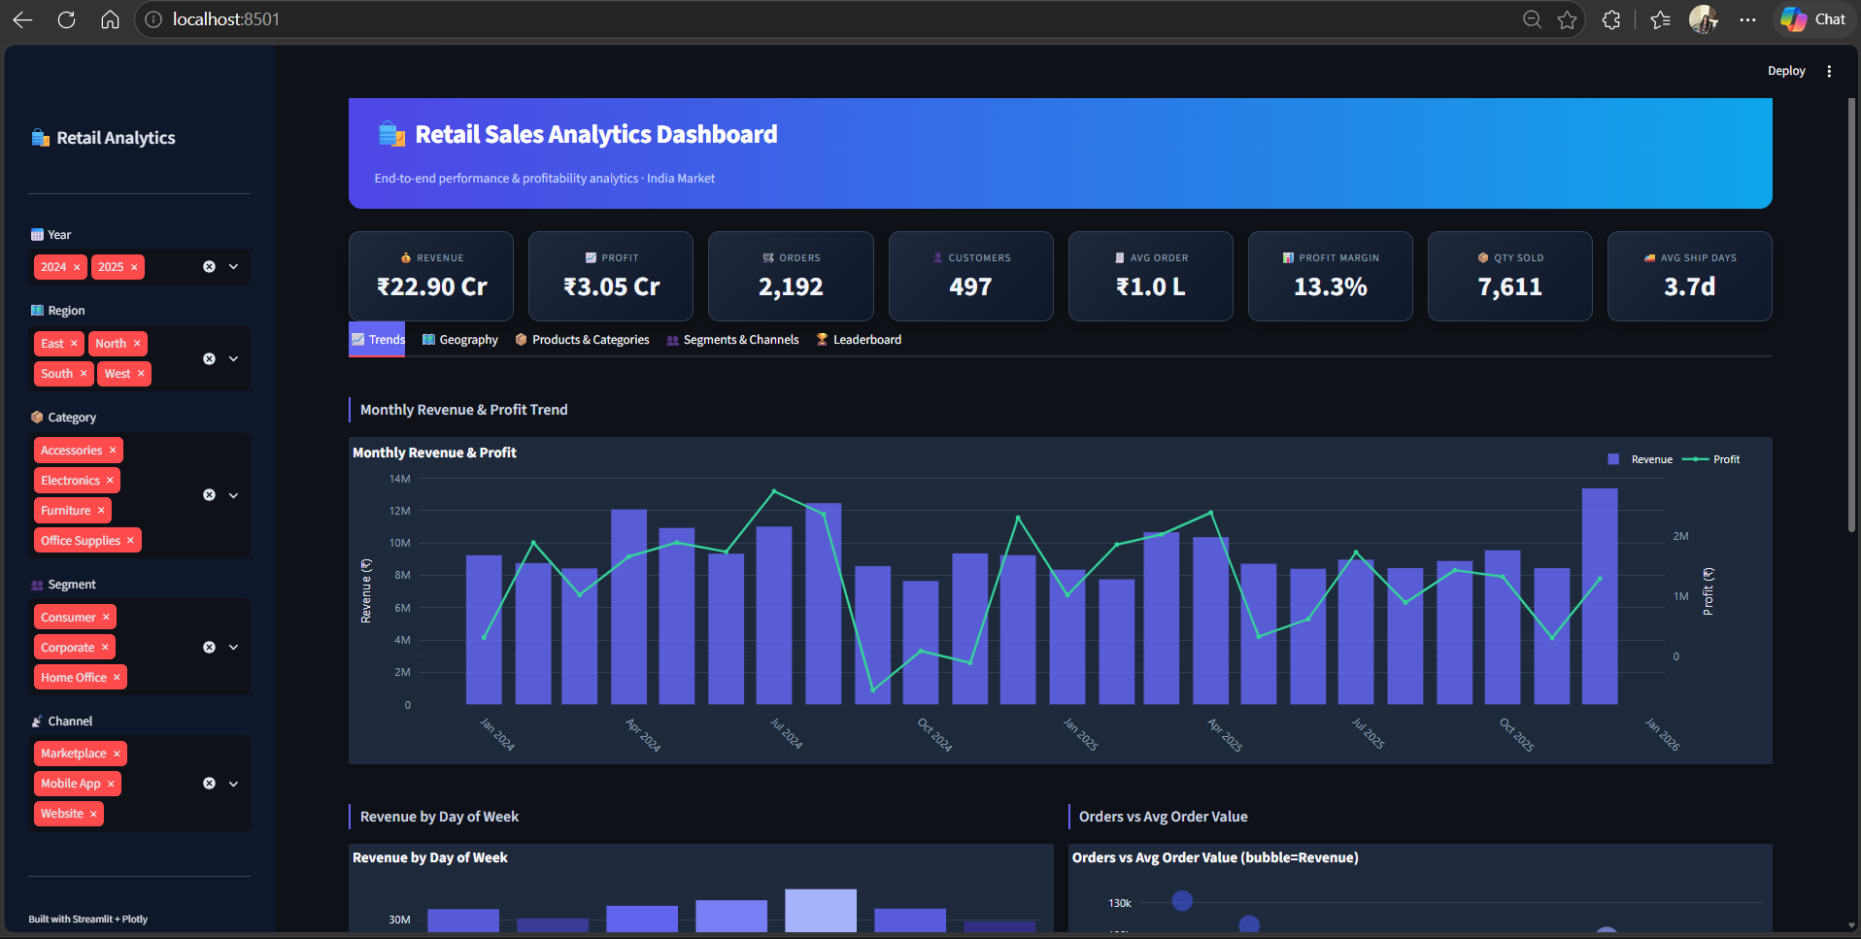
Dashboard screenshot — 1 — Trends
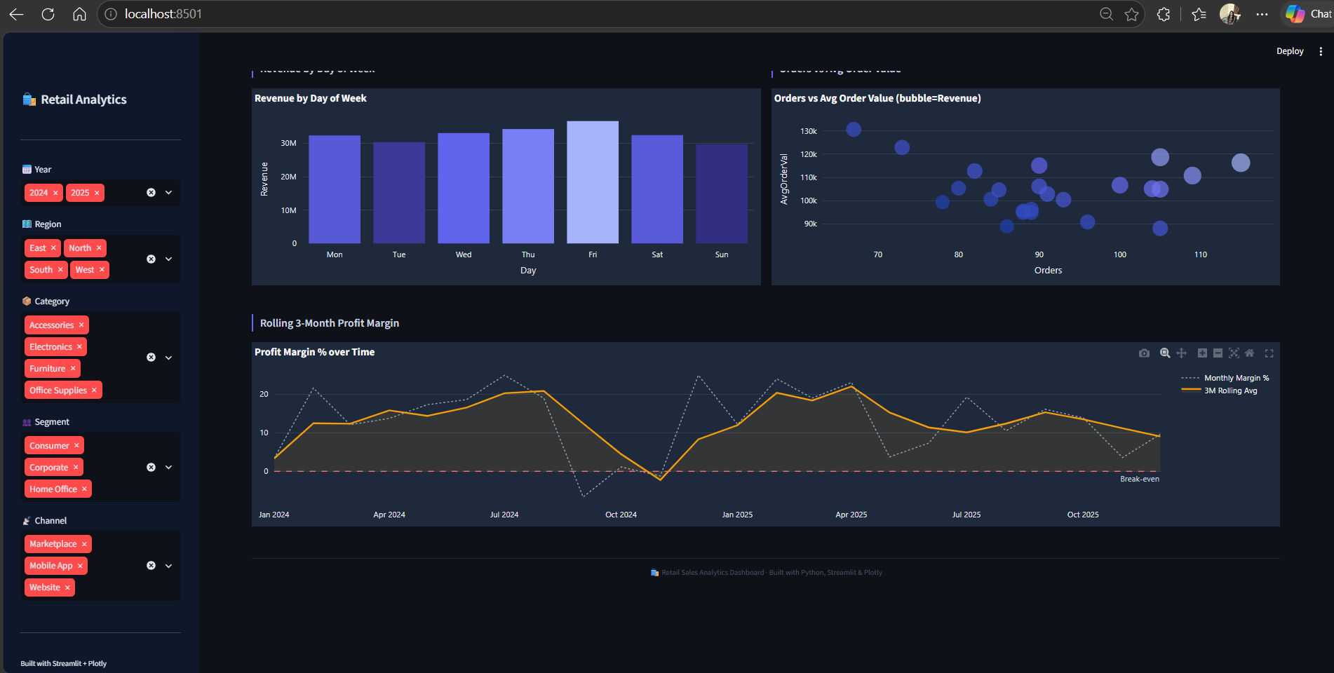
Additional view — 1 — Trends

Tab 2 — Geography
Regional revenue and margin, top cities, region-category heat map, and channel split by region.
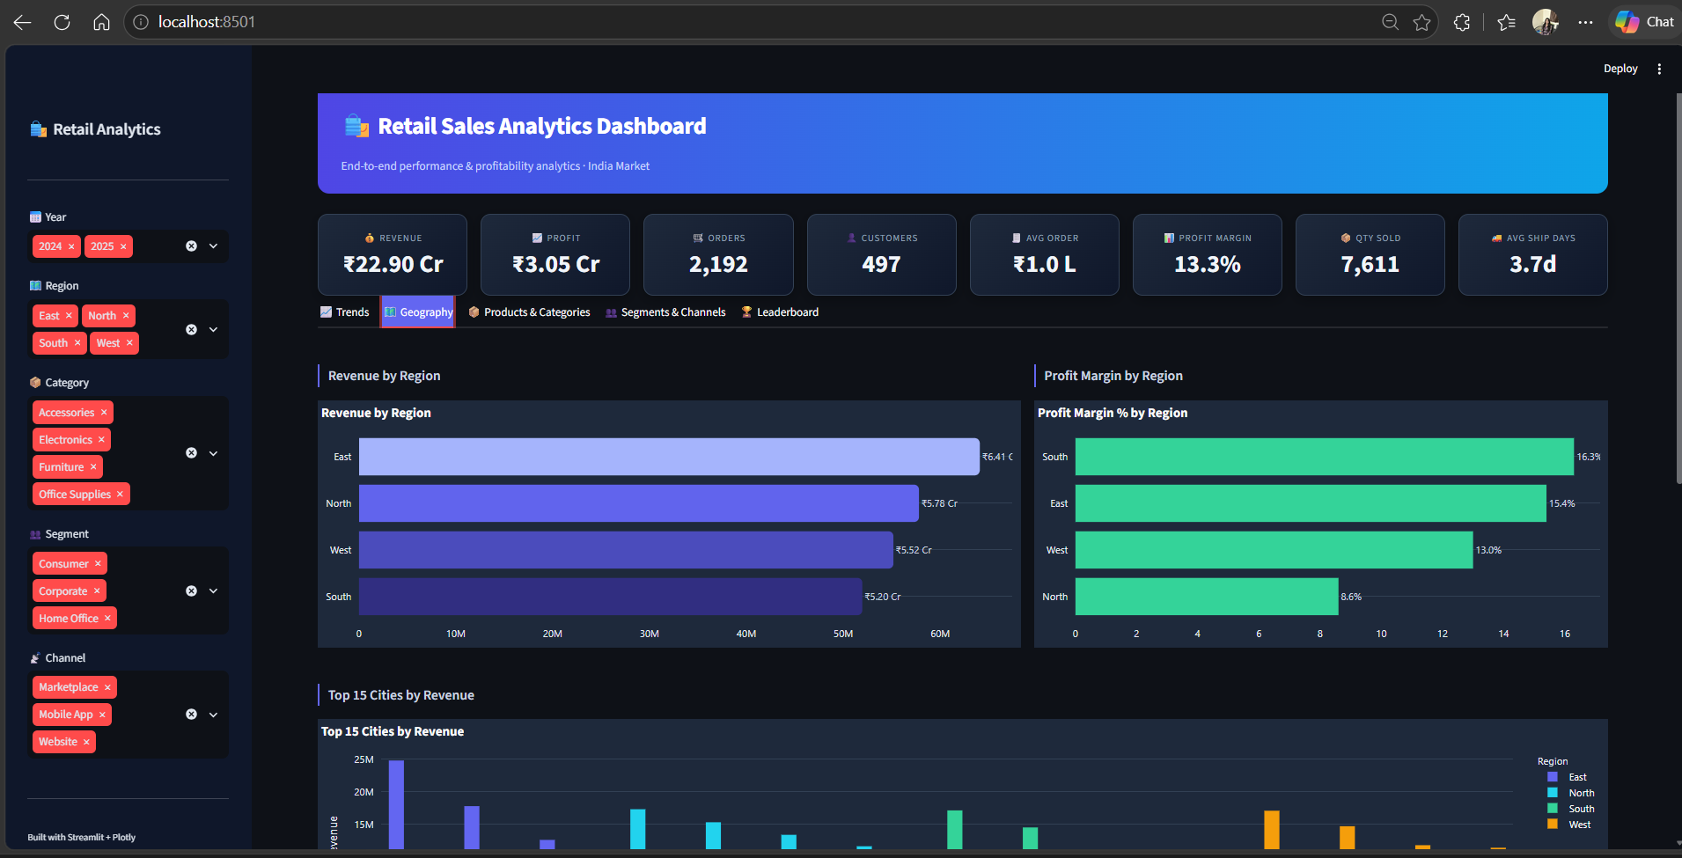
Dashboard screenshot — 2 — Geography
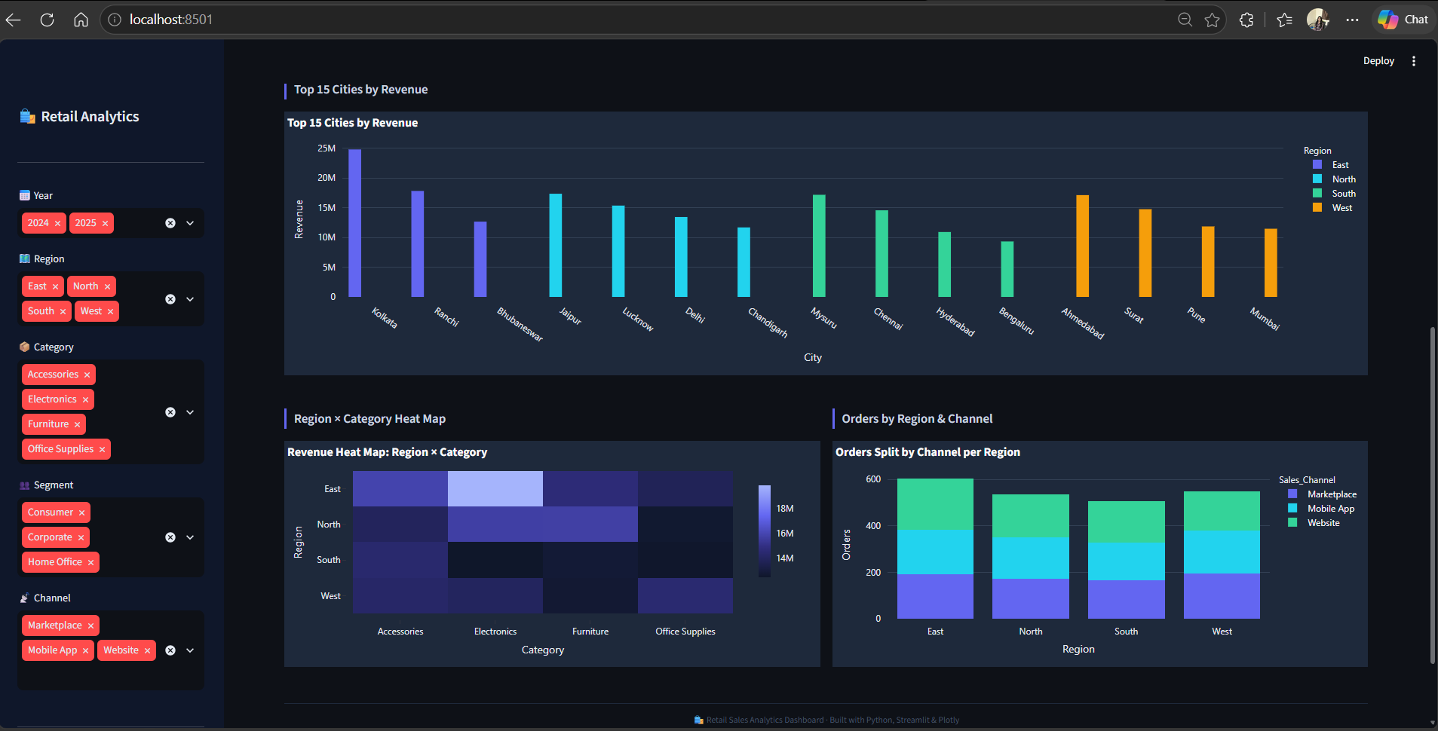
Additional view — 2 — Geography

Tab 3 — Products & Categories
Category mix, category margin, top products, discount distribution and quantity trend.
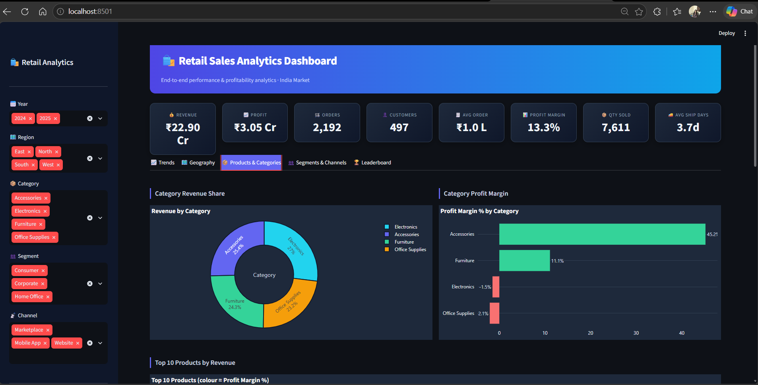
Dashboard screenshot — 3 — Products & Categories
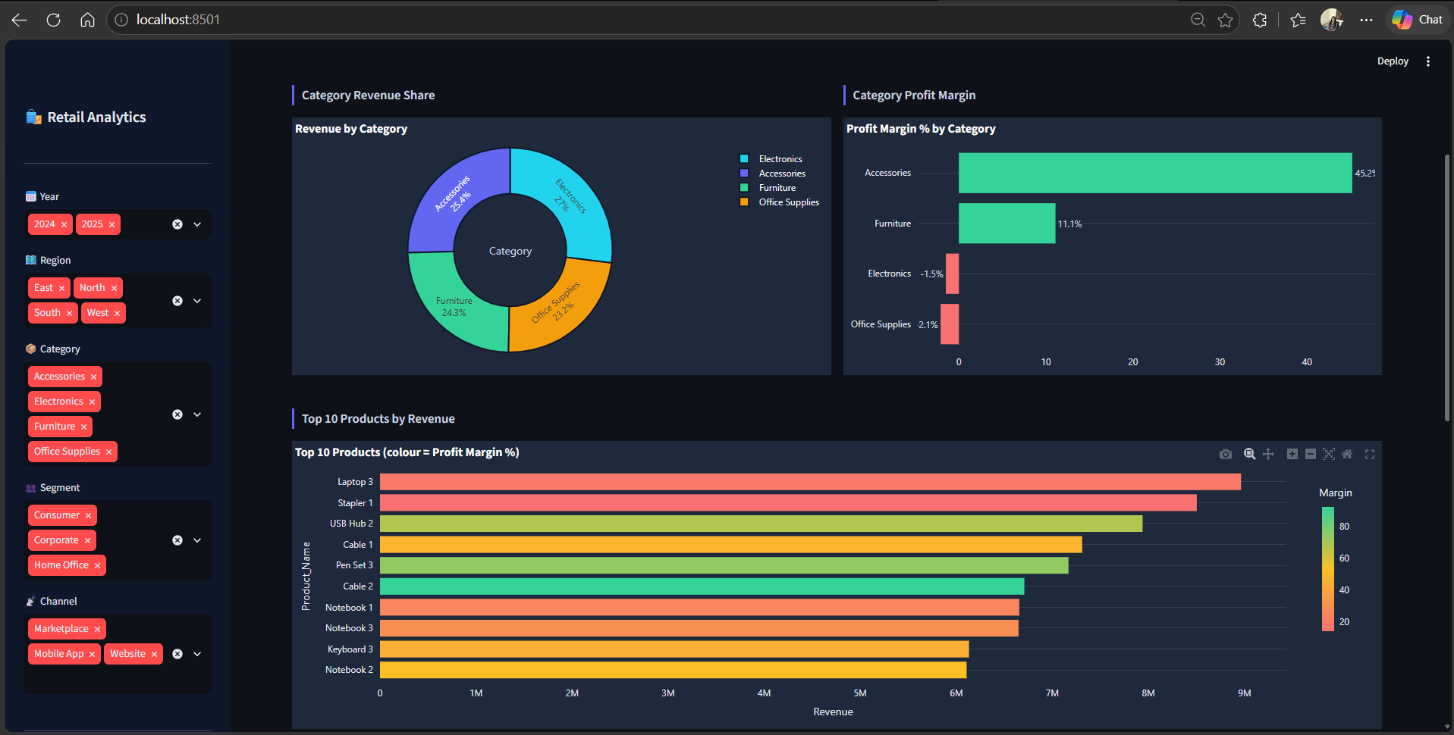
Additional view — 3 — Products & Categories

Tab 4 — Segments & Channels
Segment mix, channel comparison, segment-region heat map, payment method mix and margin by segment/category.
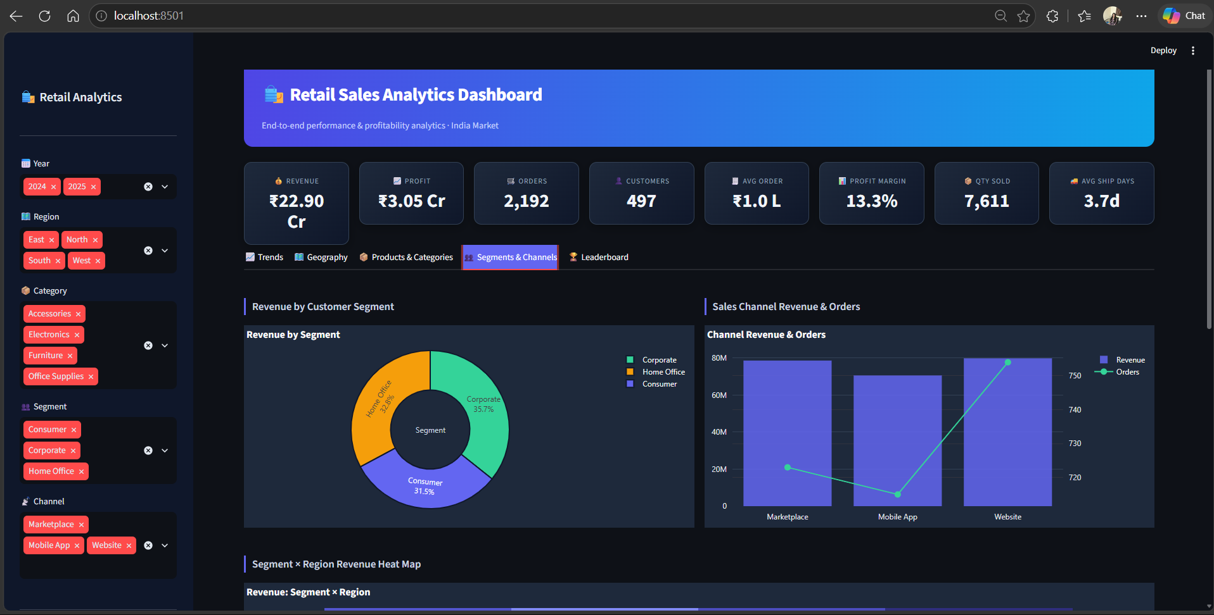
Dashboard screenshot — 4 — Segments & Channels
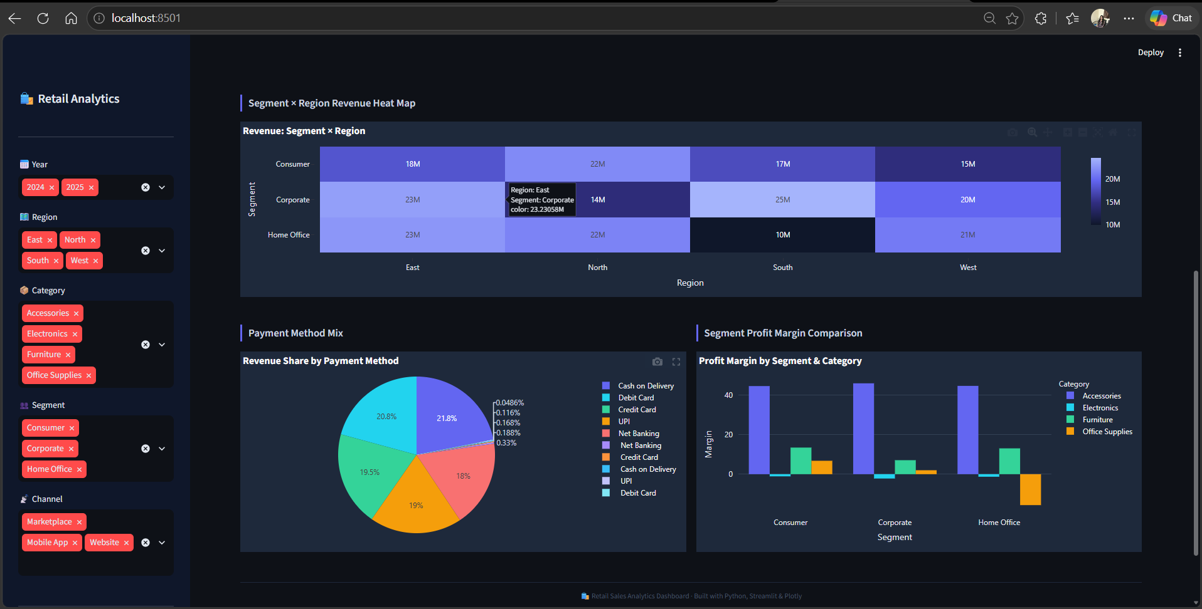
Additional view — 4 — Segments & Channels

Tab 5 — Leaderboard
Sales-representative comparison, radar chart, revenue-vs-profit view and filtered transaction explorer with CSV export.
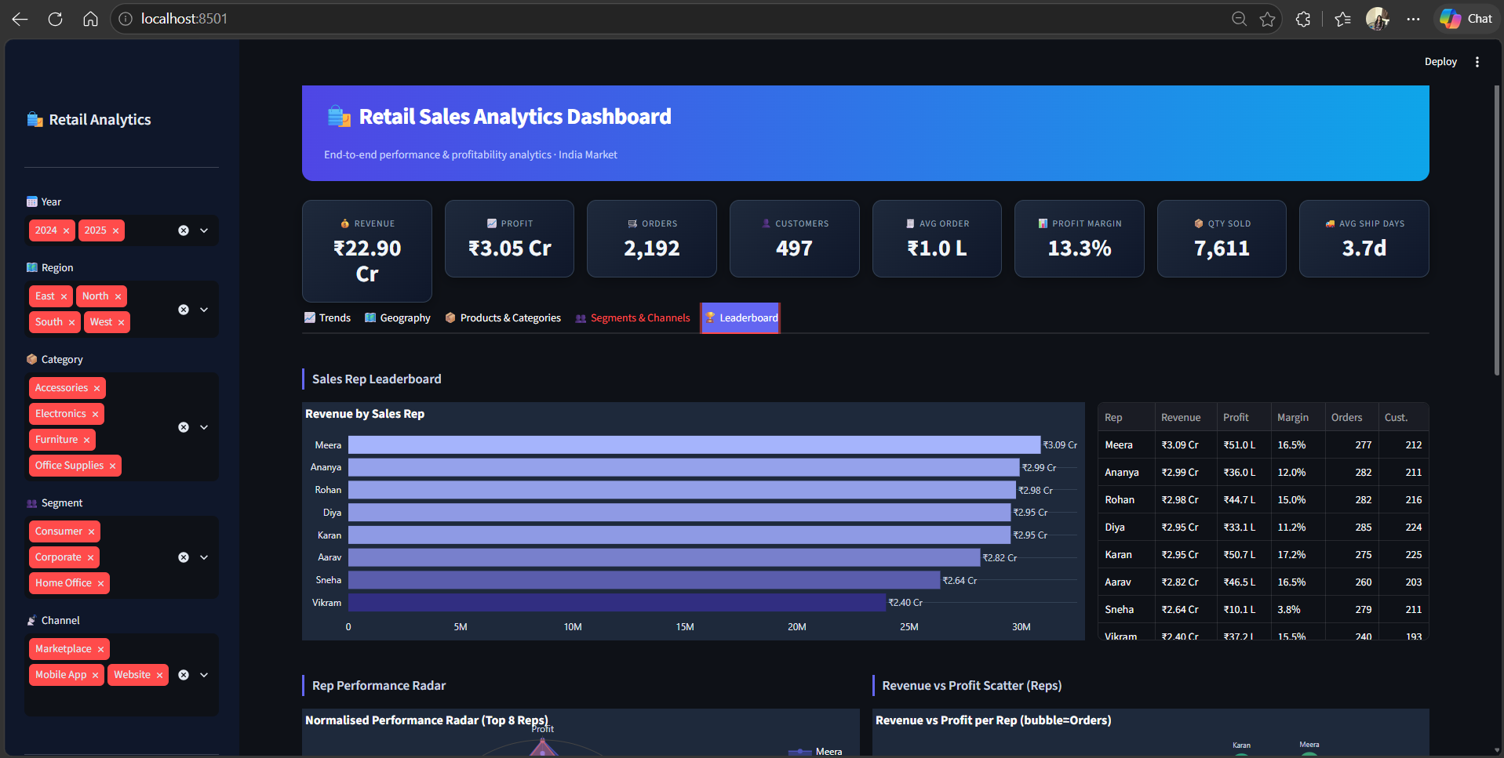
Dashboard screenshot — 5 — Leaderboard
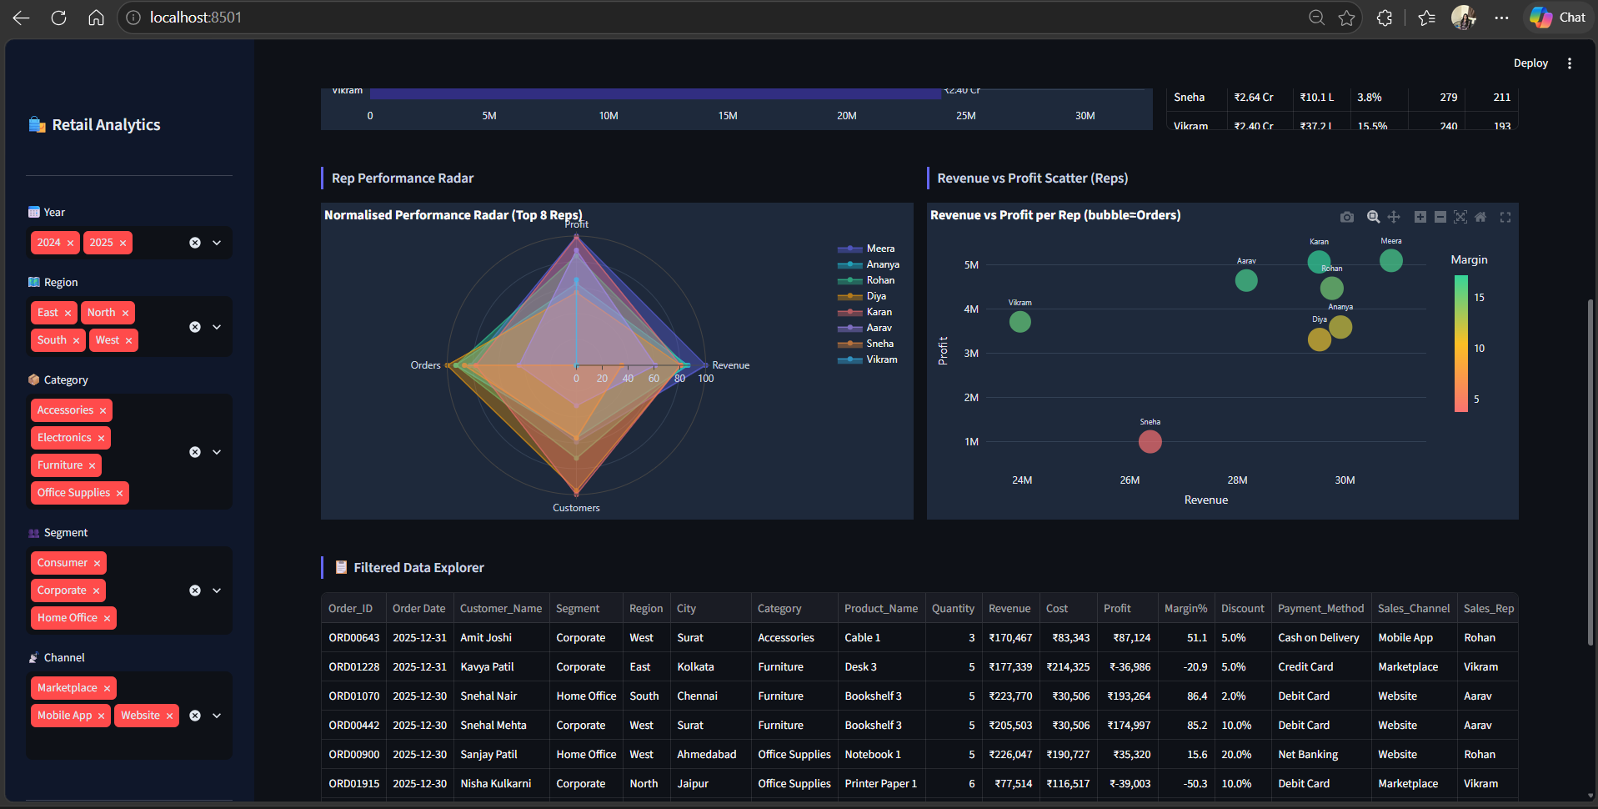
Additional view — 5 — Leaderboard

6. KPI Summary
KPI | Reported value | Interpretation
Total Revenue | ₹22.90 Cr | Overall sales generated during the analysis period.
Total Profit | ₹3.05 Cr | Aggregate profit across the cleaned transaction base.
Profit Margin | 13.3% | Overall profit as a percentage of revenue.
Total Orders | 2,192 | Unique orders after deduplication.
Unique Customers | 497 | Distinct customers represented in the dataset.
Quantity Sold | 7,611 units | Total units sold across categories.
Average Order Value | ~₹1.0 Lakh | Average revenue per order.
Average Shipping Days | 3.7 days | Average fulfilment duration.

The KPI layer provides the executive summary, while the five dashboard tabs explain the drivers behind those numbers.

7. Detailed Analysis & Insights

7.1 Revenue and profitability trends
Revenue increased through 2024, reached a peak in late 2024, declined during Q1 2025 and then recovered through mid-2025. The rolling three-month profit margin is more volatile than revenue, including several periods below zero. The analysis attributes these weak-margin periods primarily to heavy discounting in Electronics and Office Supplies; this should be treated as a diagnostic interpretation requiring further validation against product costs and pricing records.
Figure 1. Trends analysis — time-series and order-value views

7.2 Category performance
Electronics is the largest revenue category at ₹6.19 Cr, representing 27.1% of revenue, but its reported margin is -1.5%. Accessories generates ₹5.82 Cr while achieving the strongest category margin at 45.2%. Office Supplies also shows a negative margin of -2.1%. This contrast demonstrates why category decisions should consider both revenue contribution and profitability.
Category insight | Reported result
Highest category revenue | Electronics — ₹6.19 Cr (27.1% share)
Highest category margin | Accessories — 45.2%
Negative-margin category | Electronics — -1.5%
Another negative-margin category | Office Supplies — -2.1%
High-margin products highlighted | USB Hub 2 — 67.8%; Pen Set 3 — 73.8%

Figure 2. Product and category performance views

7.3 Geographic performance
East leads regional revenue at ₹6.41 Cr, followed by North at ₹5.78 Cr, West at ₹5.52 Cr and South at ₹5.20 Cr. South records the highest reported regional margin at 16.3%, while East records 15.4%. The city-level view highlights Bhubaneswar, Kolkata and Delhi among the higher-revenue markets.
Region | Revenue | Reported margin
East | ₹6.41 Cr | 15.4%
North | ₹5.78 Cr | —
West | ₹5.52 Cr | —
South | ₹5.20 Cr | 16.3%

Figure 3. Geographic performance — region and city views

7.4 Segments, channels and payments
Revenue is distributed relatively evenly across the three customer segments: Consumer contributes approximately 36%, Corporate approximately 34% and Home Office approximately 30%. Website contributes ₹7.98 Cr and Marketplace ₹7.86 Cr, while the Mobile App completes the three-channel mix. UPI and Credit Card together account for more than 55% of transaction value.
Figure 4. Segment and channel performance

7.5 Sales representative performance
The Leaderboard tab compares representatives across revenue, profit, orders and customers. The revenue-versus-profit scatter is particularly useful for identifying representatives or portfolios where high sales volume is accompanied by comparatively weak profitability. The data explorer also supports filtered transaction review and CSV export.
Figure 5. Sales representative leaderboard and transaction explorer

8. Recommendations
The recommendations below are derived from the reported dashboard patterns. They are intended as analytical actions to validate and prioritise, rather than as guaranteed financial outcomes.

1. Review Electronics pricing and discount controls
Electronics combines the highest category revenue with a -1.5% margin. Review product-level cost, pricing and discount data, and identify SKUs where discounting is eroding contribution.

2. Expand analysis of Accessories
Accessories reports a 45.2% margin on ₹5.82 Cr revenue. Review its high-performing products and customer/channel mix to identify opportunities for controlled expansion.

3. Investigate North-region margin
North generates ₹5.78 Cr in revenue but is identified in the analysis as having room for margin improvement. Examine region-level discounting, product mix and customer segment contribution before changing commercial policies.

4. Establish discount guardrails
Office Supplies shows wide discount variability and a -2.1% margin. Standard discount tiers, approval thresholds and exception monitoring can be evaluated to reduce avoidable margin erosion.

5. Evaluate Mobile App opportunities
The three channels are broadly balanced in revenue contribution. Use the dashboard to monitor Mobile App performance by customer segment, category and region before allocating incremental promotional spend.

6. Use the dashboard as a recurring management tool
Schedule regular review of revenue, margin, discount and regional KPIs. The filtered data explorer can support follow-up analysis when a KPI moves materially.

Prioritisation framework
Priority area | What to monitor | Suggested validation
Electronics | Margin, discount, SKU-level profitability | Compare selling price, discount and product cost
Office Supplies | Margin and discount variance | Review discount bands and exception transactions
North region | Revenue vs. margin | Compare mix, discounts and segment performance
Accessories | Margin and revenue | Assess high-margin SKUs and scalable demand
Mobile App | Revenue, orders and AOV | Track performance by segment and category over time

9. Conclusion
The project delivers an end-to-end retail analytics workflow, beginning with raw Excel data and progressing through data cleaning, aggregation, interactive visualisation and business interpretation. The resulting Streamlit dashboard brings five analytical perspectives—Trends, Geography, Products & Categories, Segments & Channels, and Leaderboard—into one interface.
The analysis shows that revenue alone does not fully describe business performance. The most important management signal is the variation in profitability across categories and regions. Electronics and Office Supplies require closer investigation because their reported margins are negative, while Accessories and South demonstrate stronger reported profitability.
The dashboard therefore functions not only as a reporting interface but also as a diagnostic tool. By combining global filters, interactive charts and transaction-level CSV export, it supports a repeatable process for identifying performance changes and investigating their underlying drivers.

Expected business value
- Faster access to core sales and profitability KPIs.
- Consistent analysis across region, category, segment and channel.
- Improved visibility into discount-related margin pressure.
- Ability to move from executive KPIs to transaction-level evidence.
- Reusable dashboard structure for ongoing retail performance monitoring.

Appendix A — Data Quality & Interpretation Notes

A.1 Data quality processing
- The source workbook contains 2,212 raw rows; 2,192 unique orders are used for the cleaned analytical dataset.
- Duplicate records were removed before KPI calculation.
- Whitespace and categorical case inconsistencies were normalised.
- Date fields were parsed for time-series and day-of-week analysis.
- Invalid discount tokens were replaced with 0 during sanitisation.

A.2 Interpretation cautions
- Dashboard relationships should not automatically be interpreted as causal relationships.
- Negative category margin indicates the reported profitability calculation in the dataset; product-level cost validation is recommended before commercial action.
- Statements about growth potential should be validated using additional time-series or cohort analysis.
- Scenario-based financial impacts should be calculated from validated costs, prices, volumes and discount assumptions before being used for planning.

A.3 Dashboard technology reference
Python 3.13 • pandas 2.x • openpyxl • Streamlit 1.63 • Plotly 5.x
Source workbook: Retail_Sales_Analytics_Project_Dataset.xlsx
Dashboard reference in the original report: http://localhost:8501
— End of Report —

